Get IP address of guvi.in:
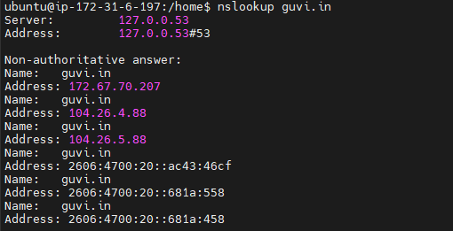
Get CPU status of machine:
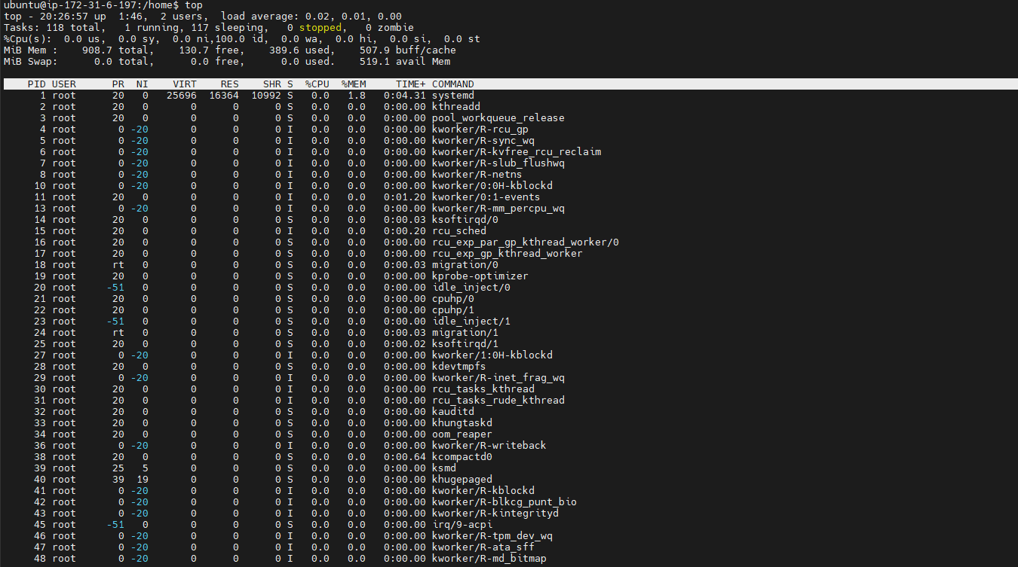
Free memory:
Test connectivity b/w two nodes:
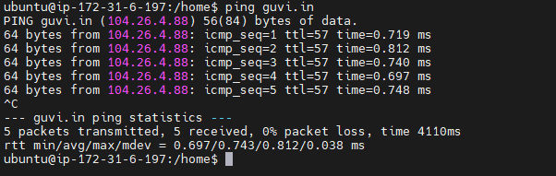

Application deployed on guvi.com:9000 but page is not opening: port 9000 is not open but port 80 is open.
